Project Design Phase-II
Data Flow Diagram & User Stories
Date | 25 September 2026
Team ID | SWTID-2026-7212
Project Name | AI StudyBuddy
Maximum Marks | 4 Marks

Data Flow Diagrams:
The following DFDs are prepared from the implemented AI StudyBuddy backend. They represent the flow between students/administrators, authentication, study-material management, AI processing through Gemini 2.5 Flash, and MongoDB data storage.
DFD Level 0

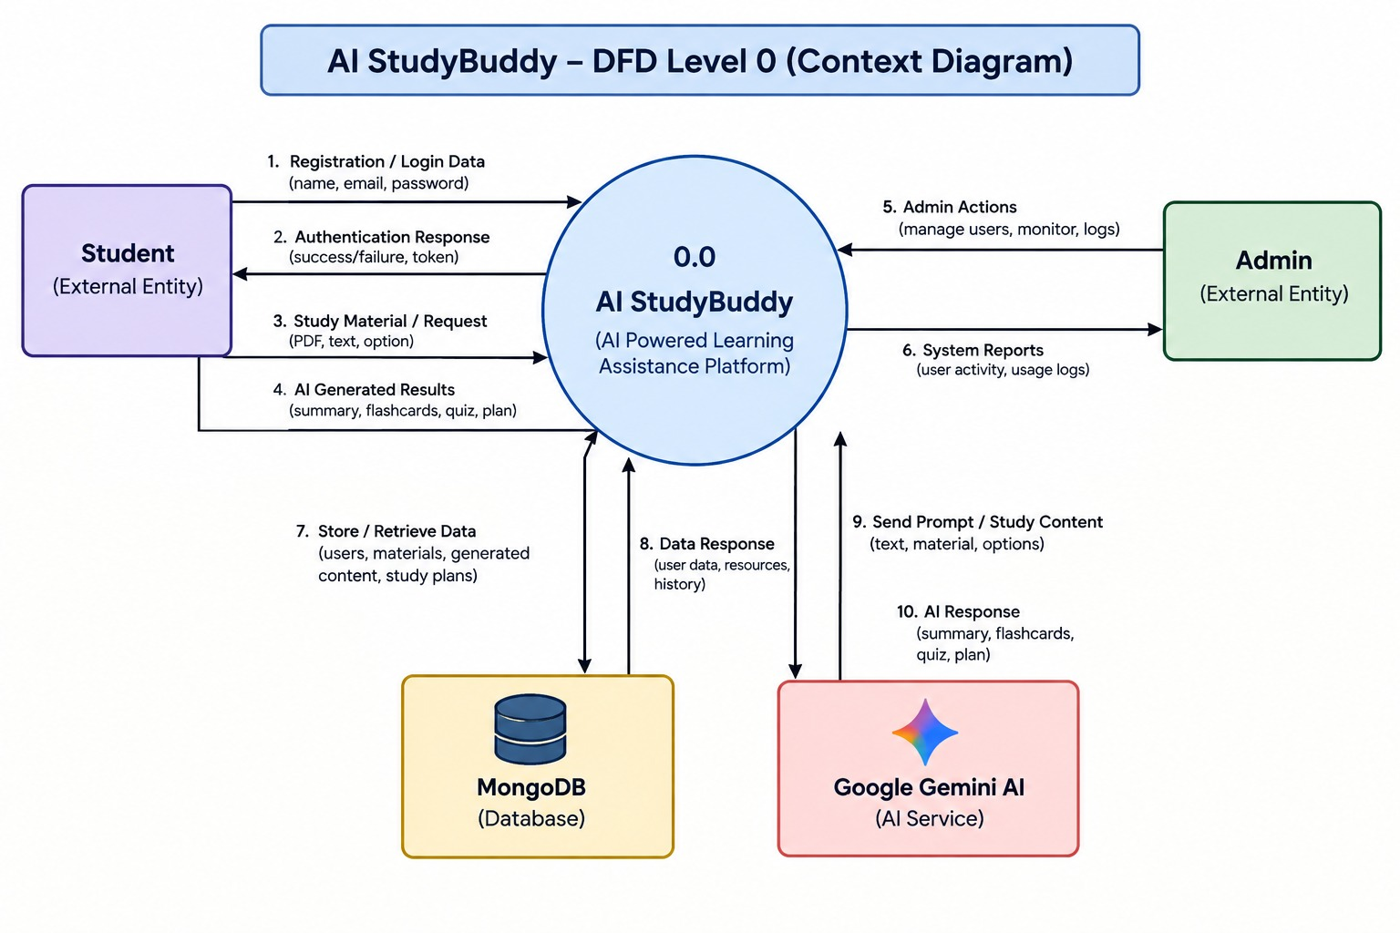

User Stories
The user stories below are based on the implemented AI StudyBuddy API. They cover authentication, study-material management, AI-powered study features, and administrator functions.
User Type | Functional Requirement (Epic) | User Story Number | User Story / Task | Acceptance criteria | Priority | Release
Student | Registration | USN-1 | As a student, I can register by providing my name, email, password, and role. | A new user is created and authentication tokens are returned. | High | Sprint-1
Student | Login | USN-2 | As a student, I can log in using my email and password. | Valid credentials return access and refresh tokens; invalid credentials are rejected. | High | Sprint-1
Student | Authentication | USN-3 | As a student, I can refresh my access token using my refresh token. | A valid refresh token returns new access and refresh tokens. | High | Sprint-1
Student | Logout | USN-4 | As a student, I can log out of the application. | The logout endpoint returns a successful logout response. | Medium | Sprint-1
Student | Study Material | USN-5 | As a student, I can upload a study material file with an optional title. | Allowed .txt, .md, or .pdf file up to 5 MB is accepted and saved as a material. | High | Sprint-1
Student | Study Material | USN-6 | As a student, I can view my uploaded study materials. | Only the student's materials are listed without exposing generated content fields in the list response. | High | Sprint-1
Student | Study Material | USN-7 | As a student, I can view a specific study material. | The requested material is displayed if it belongs to the student. | High | Sprint-1
Student | Study Material | USN-8 | As a student, I can delete my study material. | The selected material is deleted and other users' materials cannot be deleted. | Medium | Sprint-1
Student | AI Summary | USN-9 | As a student, I can generate an AI summary from my study material. | Gemini generates a concise bullet-point summary and it is saved with the material. | High | Sprint-2
Student | AI Flashcards | USN-10 | As a student, I can generate AI flashcards from my study material. | The requested number of question-answer flashcards is generated, saved, and returned. | High | Sprint-2
Student | AI Quiz | USN-11 | As a student, I can generate an AI multiple-choice quiz from my study material. | MCQ questions with options and answers are generated, saved, and returned. | High | Sprint-2
Student | AI Study Plan | USN-12 | As a student, I can generate a personalized study plan by providing my goal, daily study hours, and number of days. | Gemini returns a day-by-day study schedule based on the material and supplied preferences. | High | Sprint-2
Administrator | User Management | USN-13 | As an administrator, I can view all registered users. | A protected admin endpoint returns the user list without passwords. | Medium | Sprint-2
Administrator | User Management | USN-14 | As an administrator, I can delete a user. | The selected user and all materials belonging to that user are deleted. | Medium | Sprint-2
Administrator | Dashboard / Statistics | USN-15 | As an administrator, I can view total student and study-material counts. | The system returns the current counts of student users and materials. | Medium | Sprint-2

